**Module (HTML5) – 3**

* **WHAT ARE THE NEW TAG ADDED IN HTML5?**
* HTML5 introduced many new tags that benefit developers they are,
* <footer>tag: The <footer> tag is used to define the footer section of a web page or document.
* <header> tag: The <header> tag is used to define the header section of a web page or document.
* <main> tag: The <main> tag is used to define the main content area of a web page or document.
* <mark> tag: The <mark> tag is used to highlight text on a web page.
* <nav> tag: The <nav> tag is used to define navigation links on a web page.
* <output> tag: The <output> tag is used to display the result of a calculation or user action on an HTML form.
* **Example of nav,**
* <!DOCTYPE html>
* <html>
* <head>
* <title>Navigation Example</title>
* </head>
* <body>
* <header>
* <h1>My Website</h1>
* <nav>
* <ul>
* <li><a href="#">Home</a></li>
* <li><a href="#">About</a></li>
* <li><a href="#">Services</a></li>
* <li><a href="#">Contact</a></li>
* </ul>
* </nav>
* </header>
* <main>
* <h2>Welcome to My Website!</h2>
* <p>Lorem ipsum dolor sit amet, consectetur adipiscing elit. Sed euismod, diam vel tincidunt bibendum, velit sapien tincidunt mauris, vel aliquam nisl sapien vel velit. Sed euismod, diam vel tincidunt bibendum, velit sapien tincidunt mauris, vel aliquam nisl sapien vel velit.</p>
* </main>
* <footer>
* <p>© 2023 My Website. All rights reserved. </p>
* </footer>
* </body>
* </html>
* **HOW TO EMBED AUDIO AND VIDEO IN A WEBPAGE?**
* [To embed audio and video in a webpage, you can use the HTML5 <audio> and <video> elements](https://www.geeksforgeeks.org/how-to-embed-audio-element-in-a-html-document/).
* **example of <audio> tag:**
* <audio controls>
* <source src="audio.mp3" type="audio/mpeg">
* Your browser does not support the audio element.
* </audio>
* **example of <video> tag:**
* <video width="320" height="240" controls>
* <source src="video.mp4" type="video/mp4">
* Your browser does not support the video tag.
* </video>
* **SEMANTIC ELEMENT IN HTML5?**
* **Semantic Elements:** Semantic elements have meaningful names which tells about type of content. For example header, footer, table, … etc. HTML5 introduces many semantic elements as mentioned below which make the code easier to write and understand for the developer as well as instructs the browser on how to treat them.
* article
* aside
* details
* figcaption
* figure
* footer
* header
* main
* mark
* nav
* section
* **example of article,**
* <!DOCTYPE html>
* <html>
* <head>
* <title>Article Tag</title>
* <style>
* h1 {
* font-size:50px;
* Text-align:left;
* }
* p {
* font-size:25px;
* text-align:left;
* margin-top:-40px;
* }
* </style>
* </head>
* <body>
* <article>
* <h1>vraj thakkar</h1>
* <p>Lorem ipsum dolor sit, amet consectetur adipisicing elit. Perspiciatis, magnam.</p>
* </article>
* </body>
* </html>

**Output**

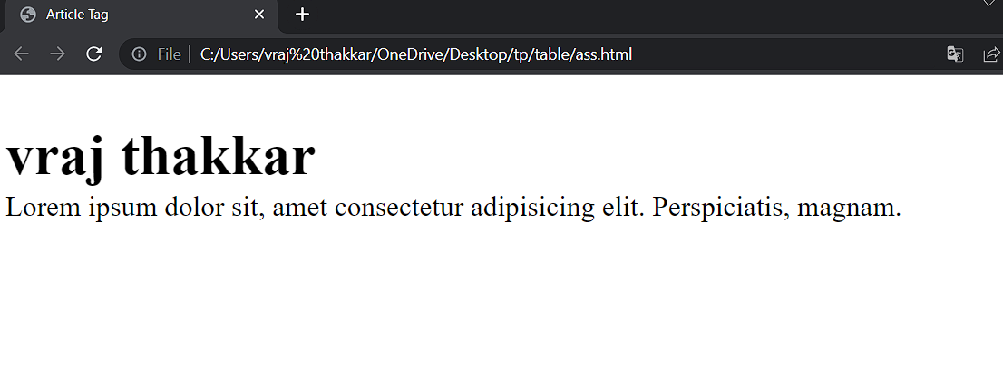

* **CANVAS AND SVG TAGS?**
* **CANVAS:-**
* Canvas is a lower-level browser standard API that allows developers to **imperatively** “draw” directly onto the image by issuing a series of commands.
* [Canvas images are created by adding a <canvas> element to the HTML and then manipulating that element via the JavaScript DOM API](https://www.w3schools.com/html/html5_svg.asp).
* **SVG:-**
* SVG stands for Scalable Vector Graphics
* SVG is used to define graphics for the Web.
* The html <svg> element is a container for svg graphics.
* SVG has several methods for drawing paths, boxes, circles, text and graphic images.
* <!DOCTYPE html>
* <html>
* <body>
* <svg width="100" height="100">
* <circle cx="50" cy="50" r="40" stroke="green" stroke-width="4" fill="yellow" />
* </svg>
* </body>
* </html>
* **OUTPUT**

